Internal CA Server Implementation and Certificate.

Pre-Requisite:
- One new VM or existing windows 2019/2022 VM.
- Domain Controller is Required, if not then we need to create.
- Manual Host File entries required and Root CA Certificate installed on client Machines.
Note: If Active Directory domain controller is present in client environment then we can use the ROOT CA certificate to client machines.
Steps Involved:
- Adding Domain Services role and Configuration.
- Adding CA Role and Configuration.
- Creating CSR and generating the Certificate
- Installing Certificate on the Server and Client machine.
- Exporting the Certificate for use in other server’s.
Step1: Adding Domain Services Role and Configuration
- Open the server manager, as shown below:
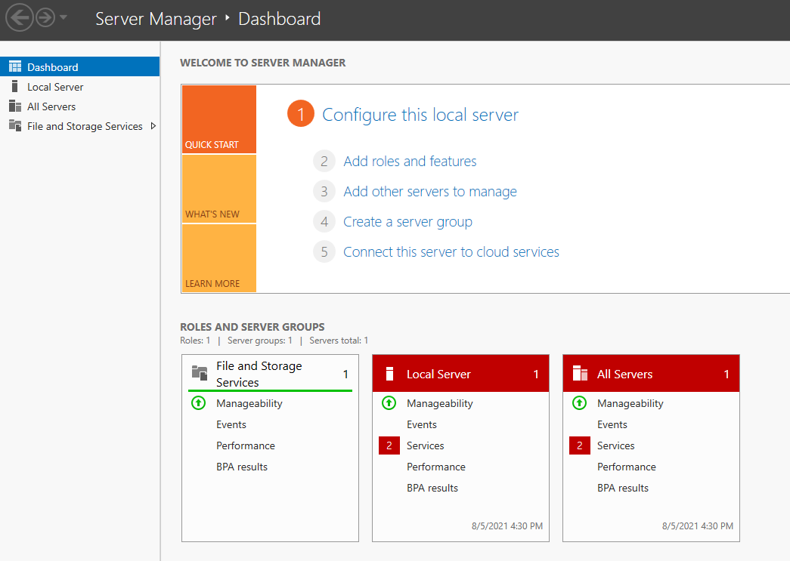
- Click ‘Add roles and features’, and click ‘Next’
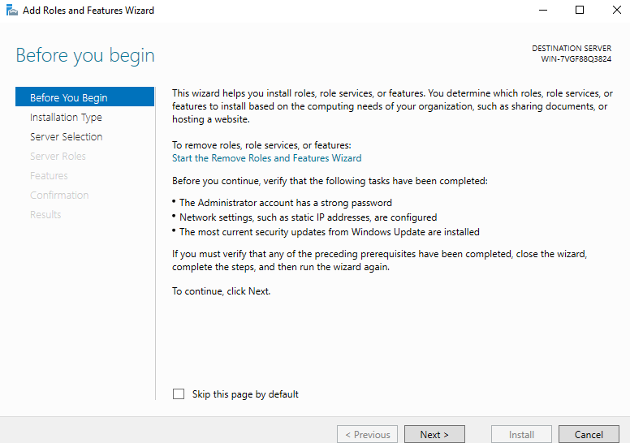
- Select ‘Role based or feature-based installation’ and click ‘Next’
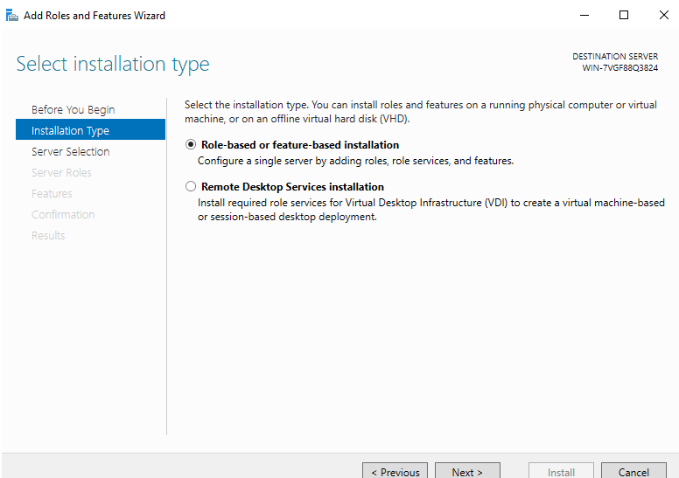
- Select a server from the server pool. It is local machine by default, so go to the next step directly
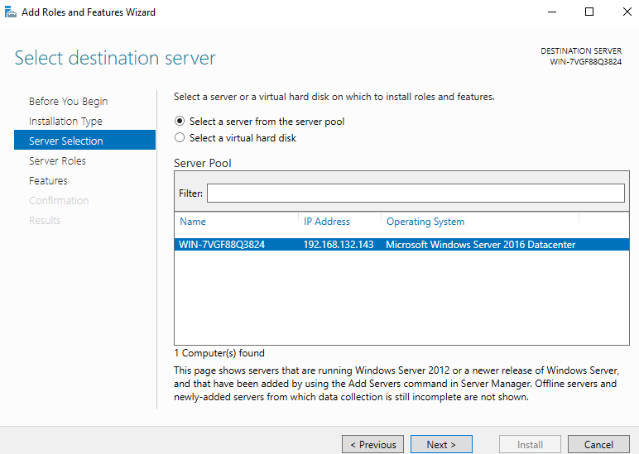

- Select ‘Active Directory Domain Services’ and add default features
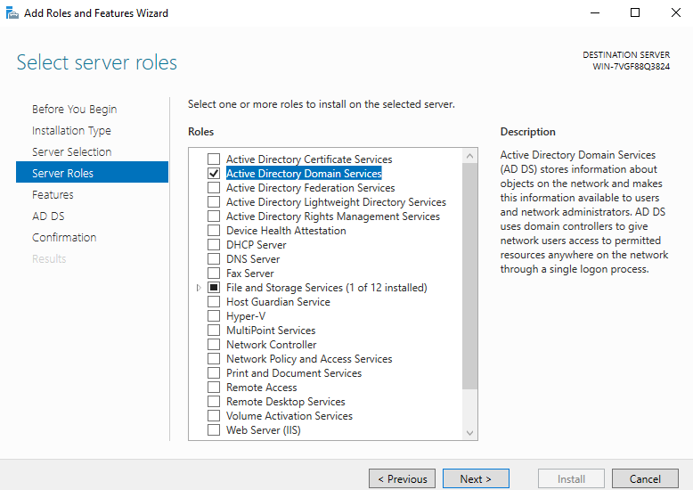
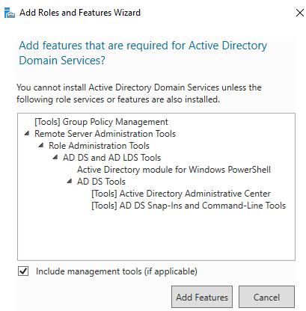
- Directly select the next step
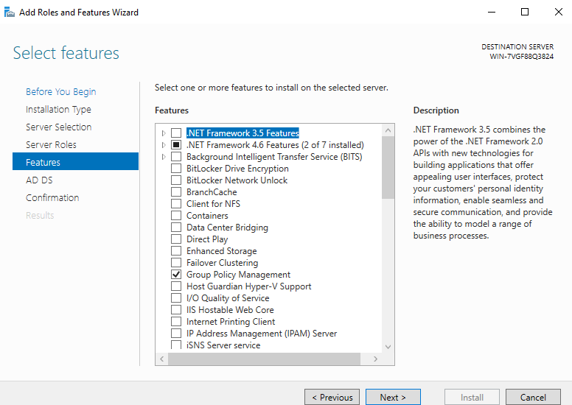
- Select next directly in the ad AD DS interface, and then confirm the installation selection in the interface and click ‘Install’
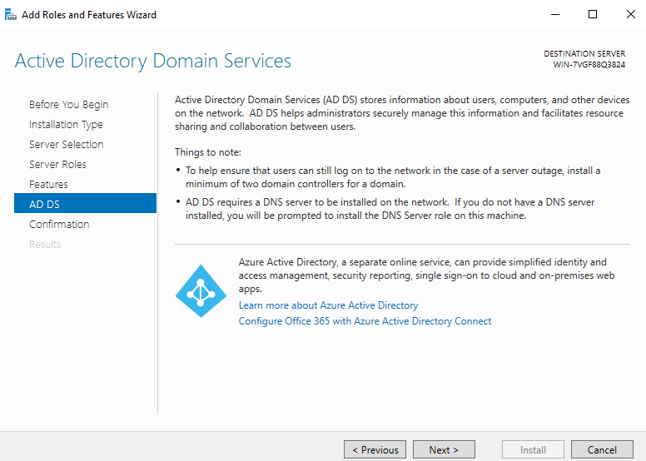
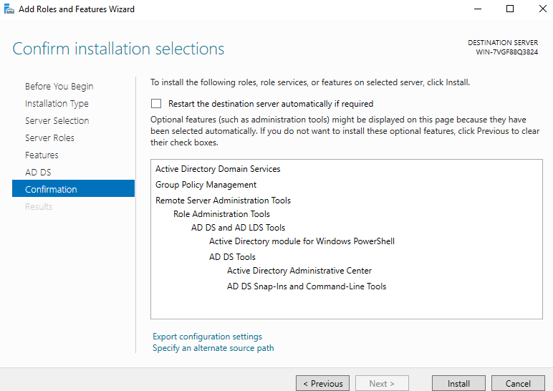
- Installation succeed, ready for configuration
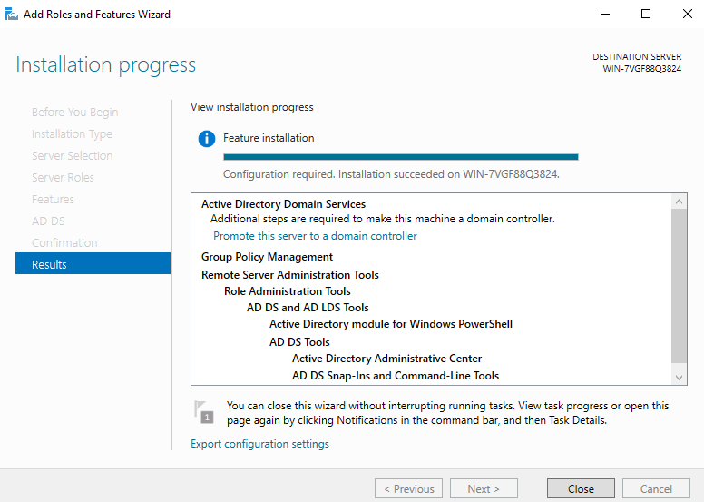
- Click the yellow flag in the upper right corner, click ‘Add Roles and Feature’, the interface will appear, and then click ‘Promote this server to a domain controller’
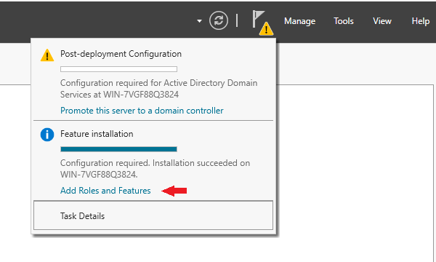
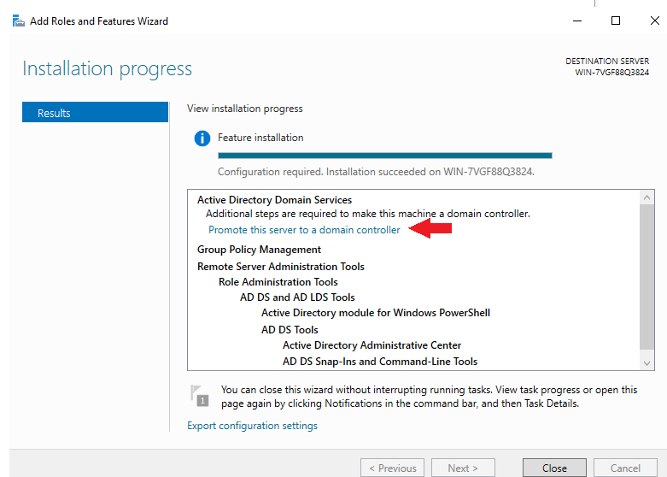
- Select ‘Add a new forest’, and set a domain name by your will, click ‘Next’
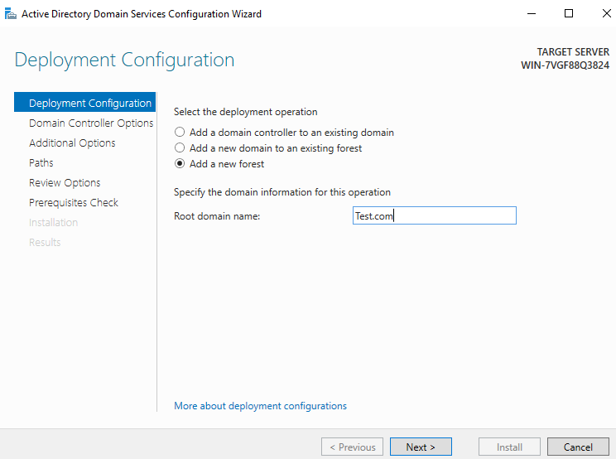
- Then set the password and click ‘Next’. Note that the previous function level must be the model of the server host. By default, it will be your own server, but sometimes it will be different
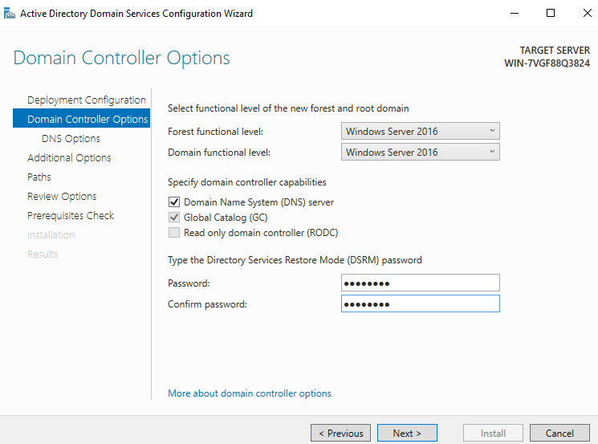
- The DNS setting prompt cannot be set. Click ‘Next’ directly. The DNS server will be installed automatically by default in the later installation process
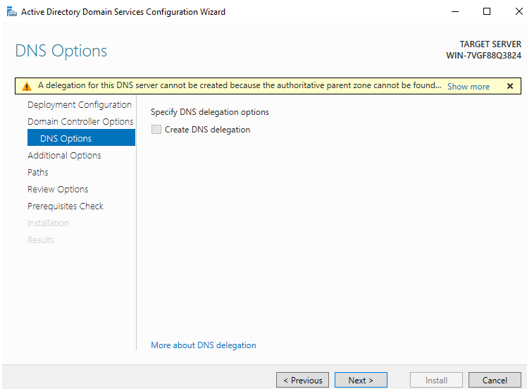
- The NetBIOS name system will be set by itself, and you can directly go to next step
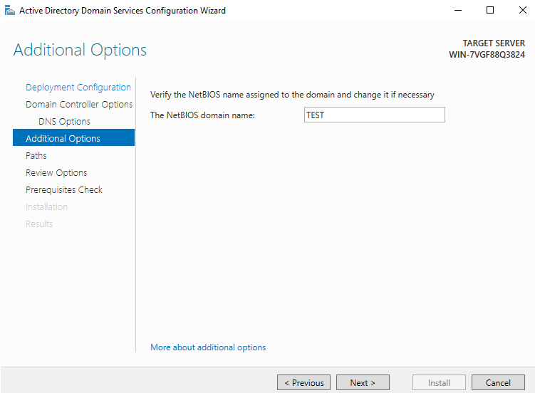
- You can also directly use the path by default and go to the next step
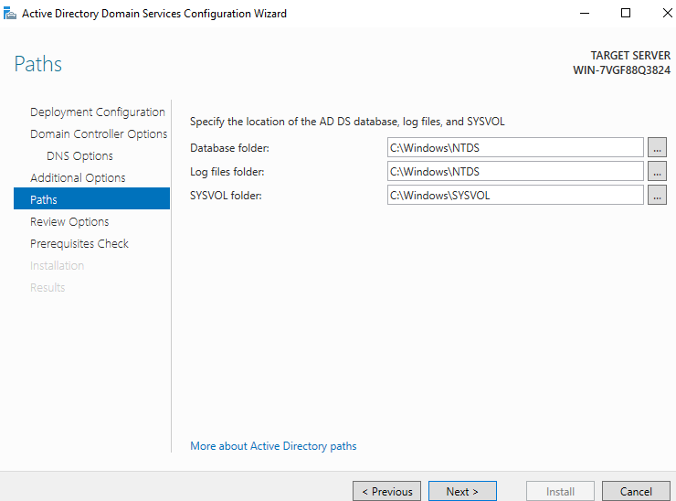
- View options. Go to the next step directly. From the view script, you can see that DNS will be automatically installed in the script
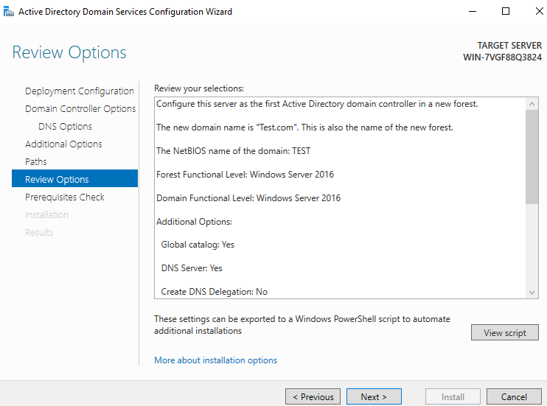
- Click on Install and after the configuration is completed, server will restart automatically.
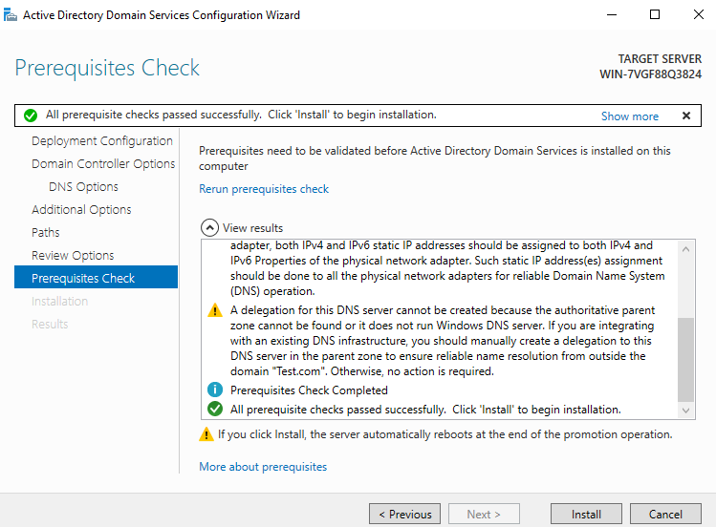

Step 2: Adding CA role and Configuration.
- Click ‘Add roles and features’, and click ‘Next’


- Select ‘Role based or feature-based installation’ and click ‘Next’

- Select a server from the server pool. It is local machine by default, so go to the next step directly.


- Select ‘Active Directory Certificate Services’
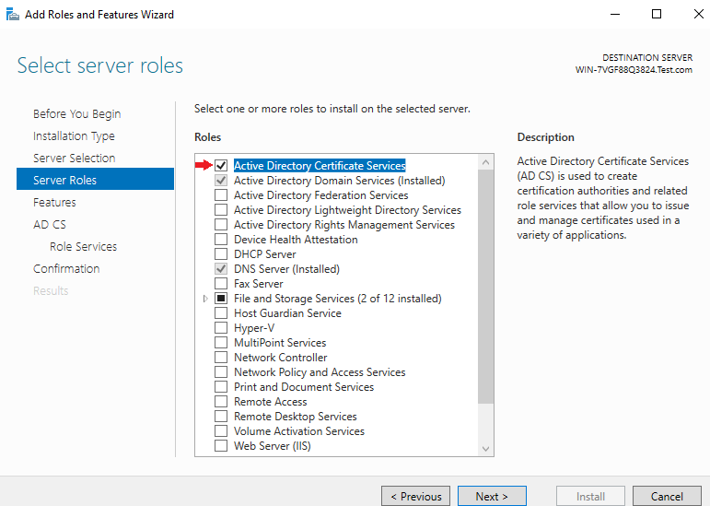
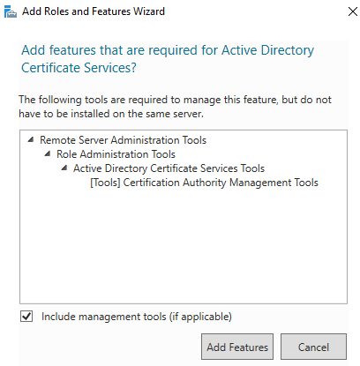
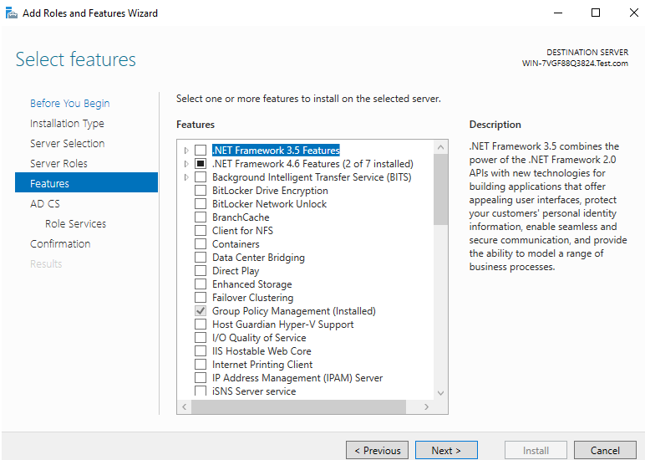
- Select ‘Add’. You do not need to select in the previous step. Go to the next step directly and select below four role services and click on next.
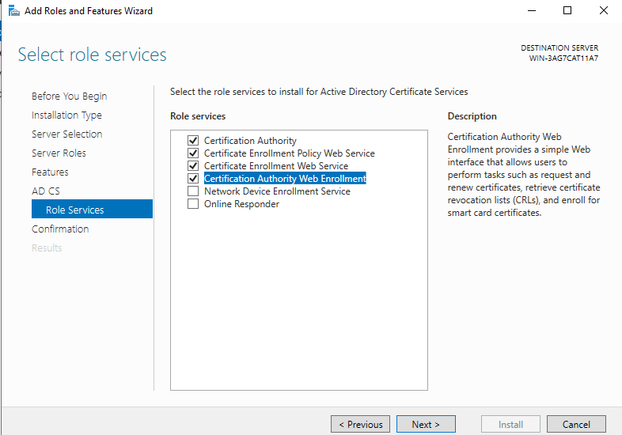
- Click ‘Next’ until the ‘Confirmation’ page shows up, click ‘install’
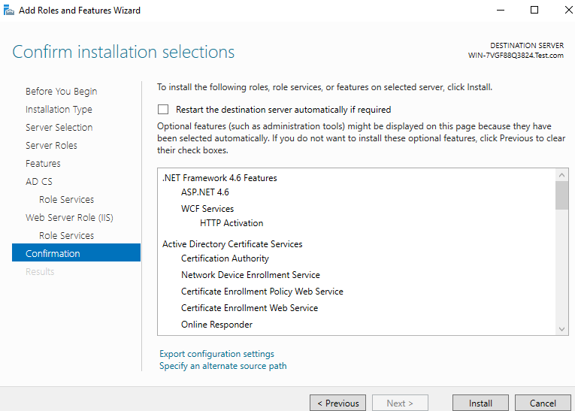
- Directly click ‘Configure Active Directory Certificate Services on the destination server’ on the installation completion interface.
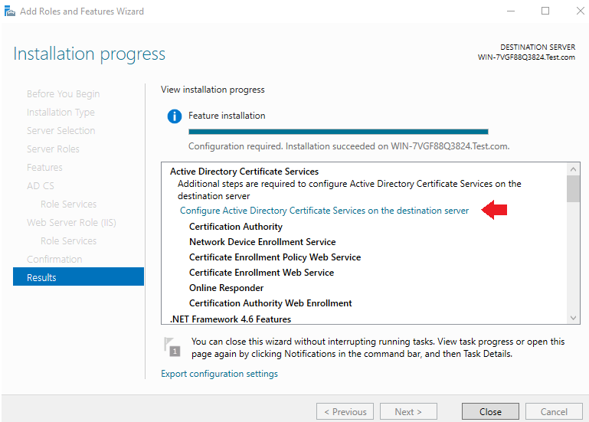
- Credentials will be added automatically. Click ‘Next’ directly. Please notice that you must login as this domain ‘s admin or enter the domain admin in the ‘Credentials’ blank, otherwise you may not be able to install some features in the next steps.
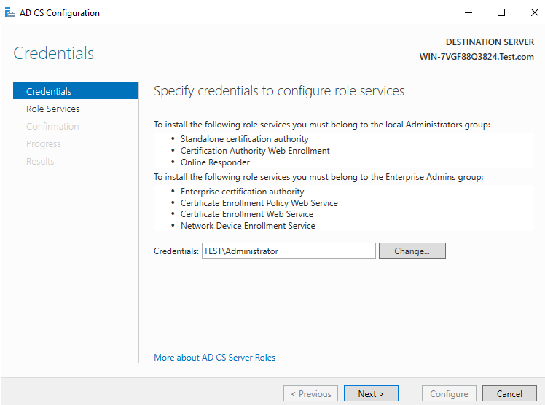
- Select below mentioned two services and click on next, rest of the service role will be installed after the CA roles is installed.
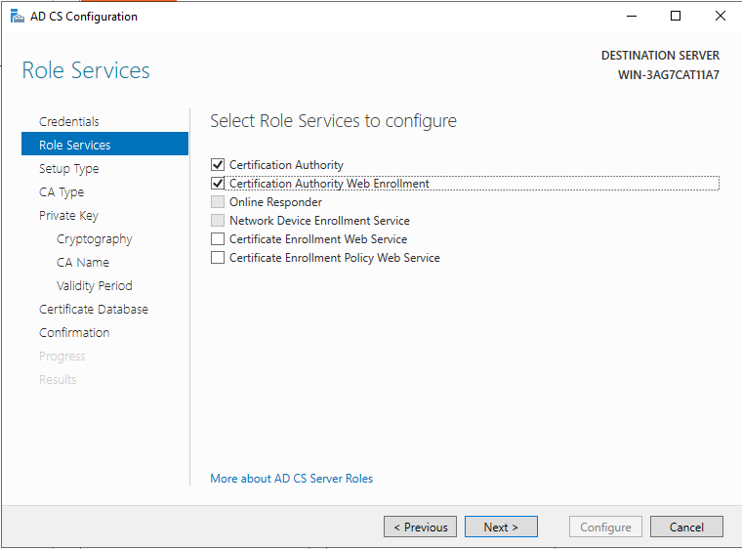
- The specified type must be ‘Enterprise CA’. If this option is gray and not optional, you need to see whether the domain configuration is correct(Normally this is because the current user is not a domain administrator, please see previous two steps).
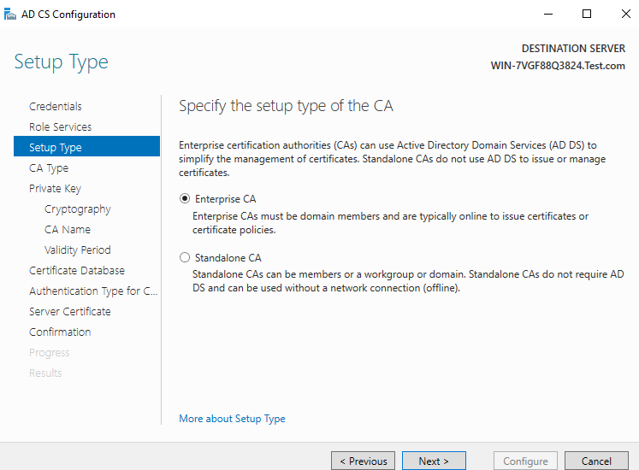
- Select the default CA type. The default is ‘Root CA’. go to the next step.
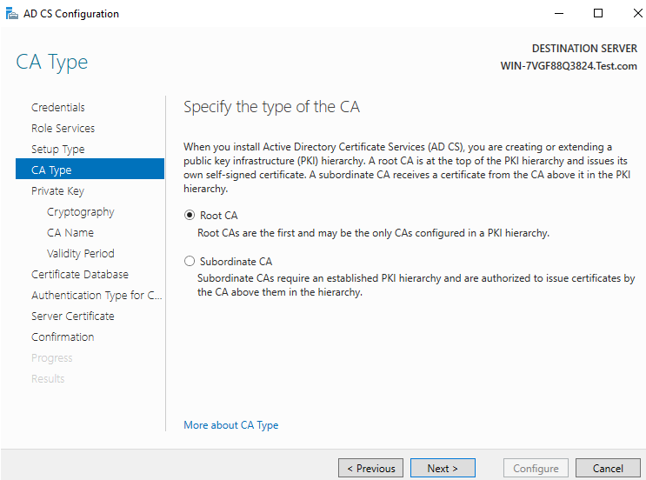
- Select the default private key type, create a new private key, and go to the next step directly.
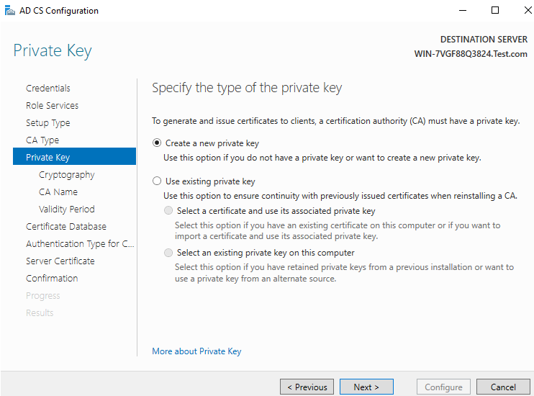
- Select the encryption algorithm. The default is SHA256 encryption algorithm. The current calculation 2048 is the key length(Please notice the support list of your security key).
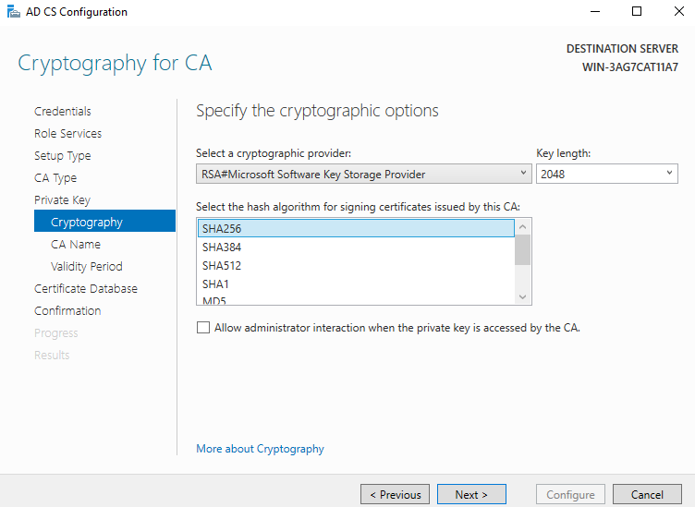
- The CA host name will be generated directly by default, we can modify it as well.
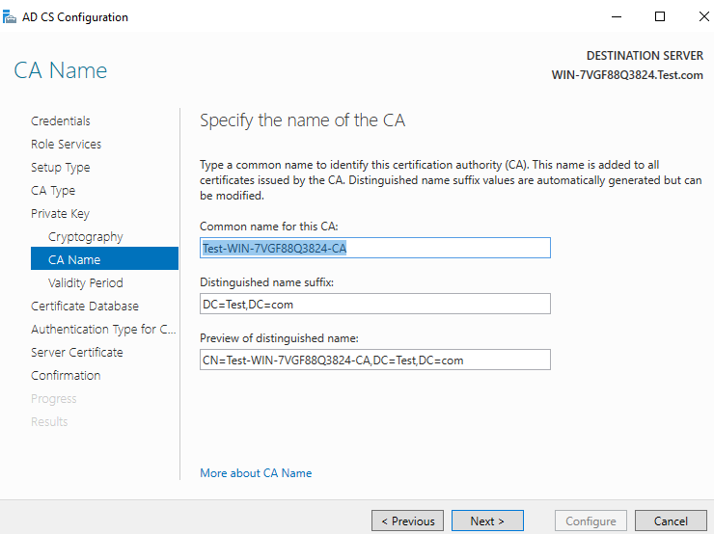
- Select the validity period, which is 5 years by default.
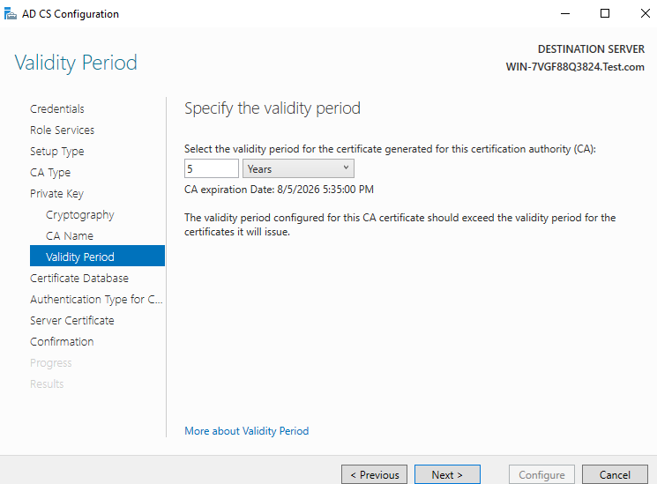
- The database location will also be generated automatically. Next.
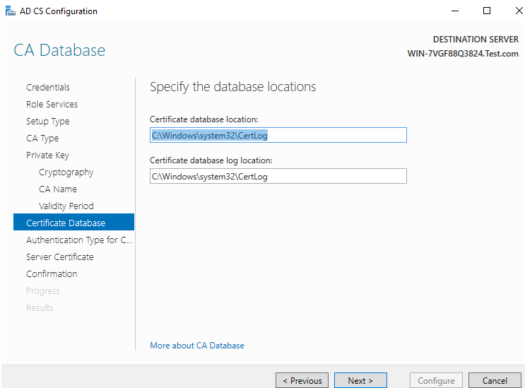
- Confirm and click on configure.
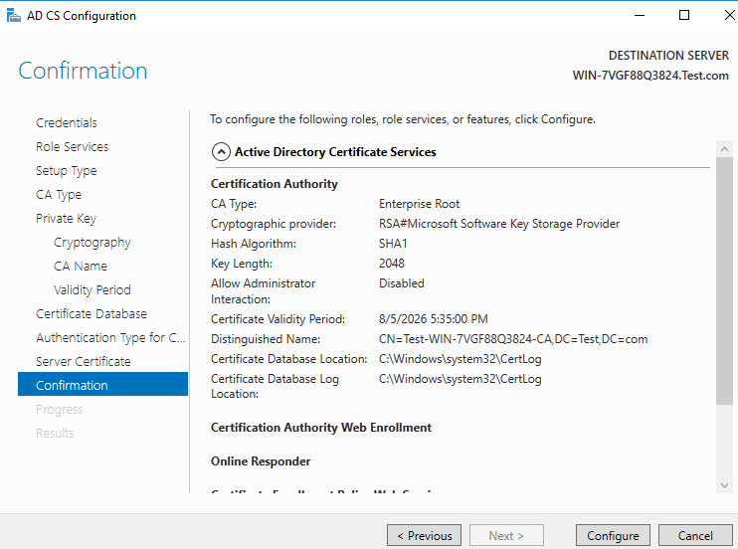
- Configuration Succeeded.
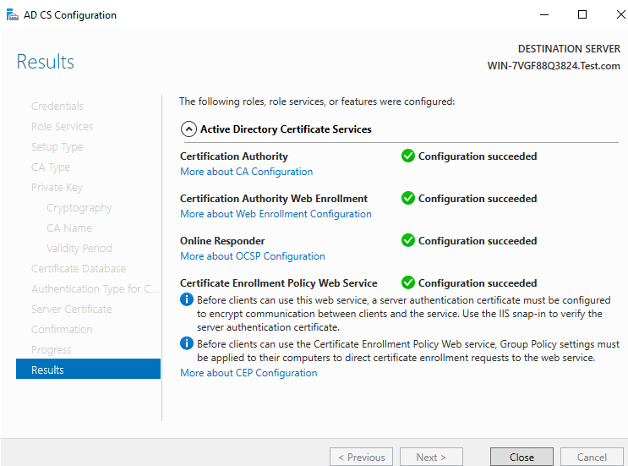
- Click Yes on the configuring additional service role.
- Credentials will already populated in the specify credentials page, click on next.
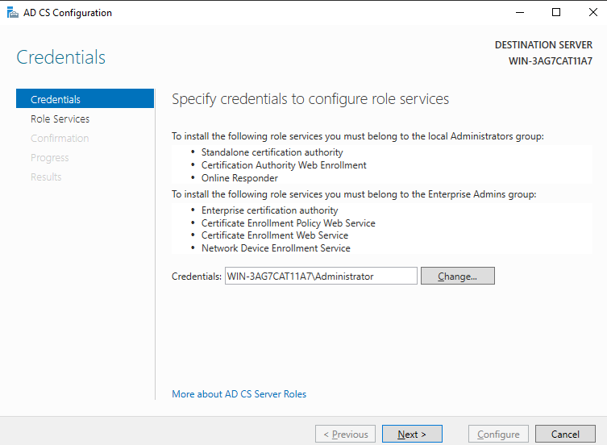
- Select other two services highlighted and click on next.
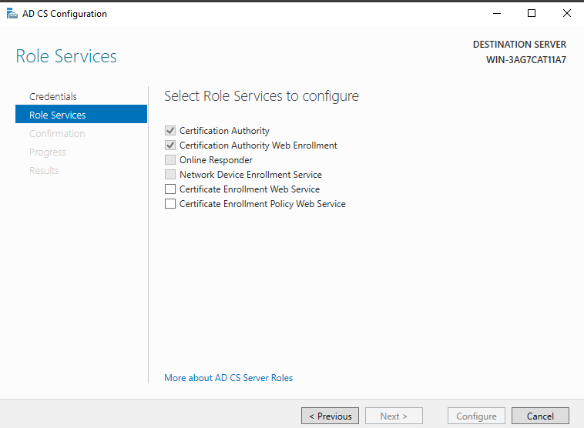
- Select Windows Integrated Authentication on the CEP authentication type page and click next.
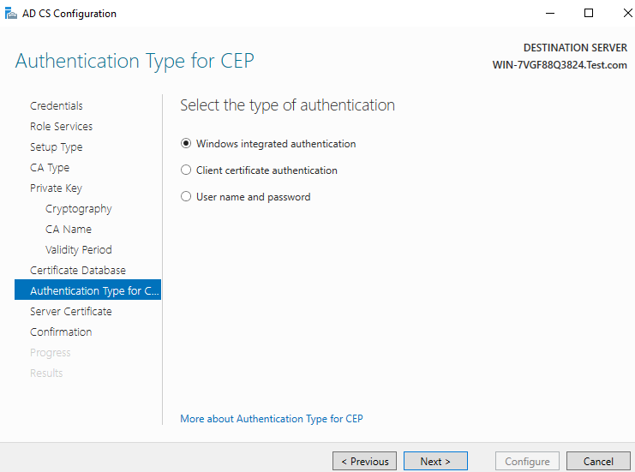
- Click on choose and assign a certificate for SSL later and click on next.
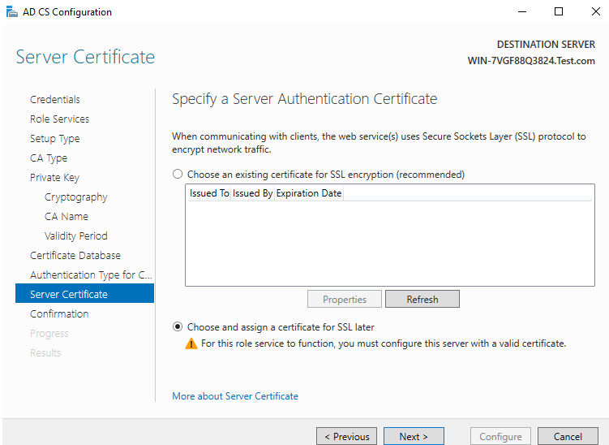
- Confirm and click on Configure.
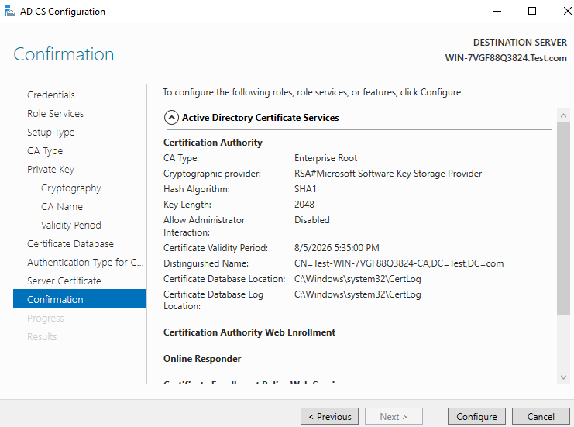
- CA Role is installed and configured, open CMD and Run below command.
certutil -setreg policy\EditFlags +EDITF_ATTRIBUTESUBJECTALTNAME2
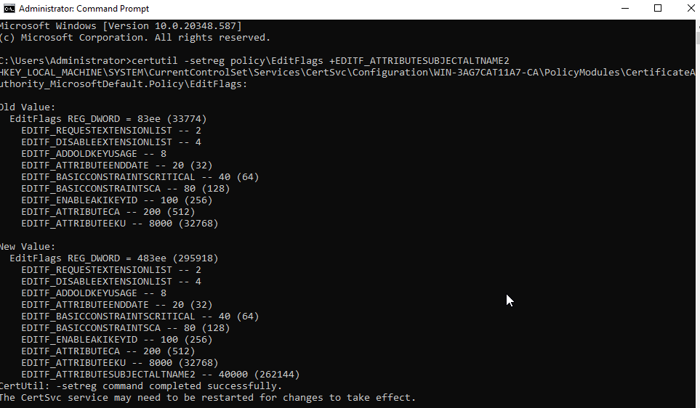
- Restart the CA service by running below commands:
Net stop certsvc
Net Start certsvc

- Open Browser and type localhost/certsrv on the CA server, below page will open.
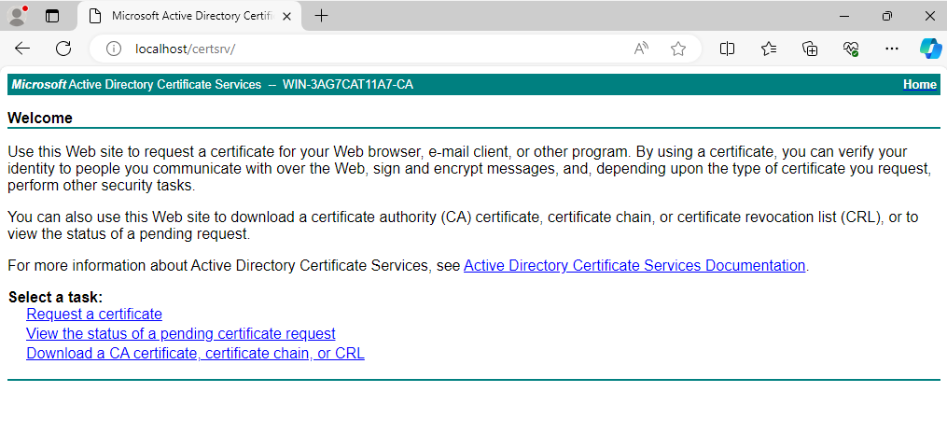
- CA server configuration is completed.
Step 3: Creating CSR and Generating Certificate.
- Now come to the IIS server and click on Server Certifcate and create CSR. Fill the details in CSR form and click on next.
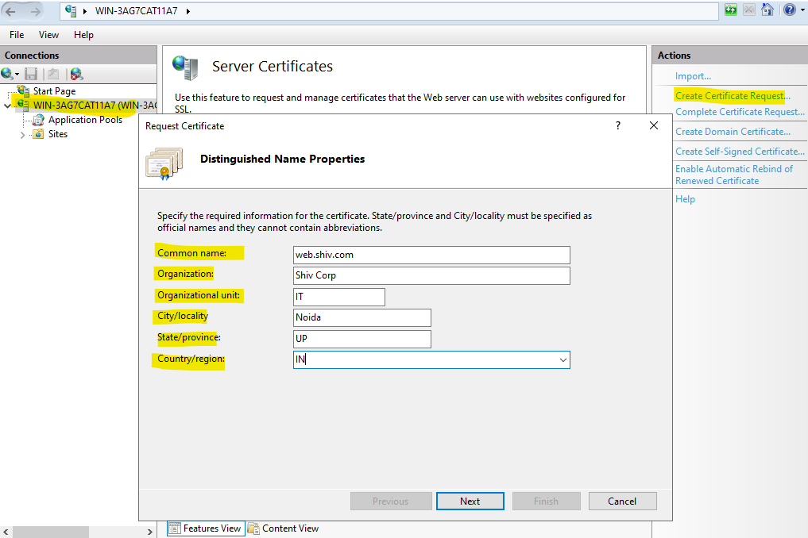
- Select 2048 bit length and click on next.
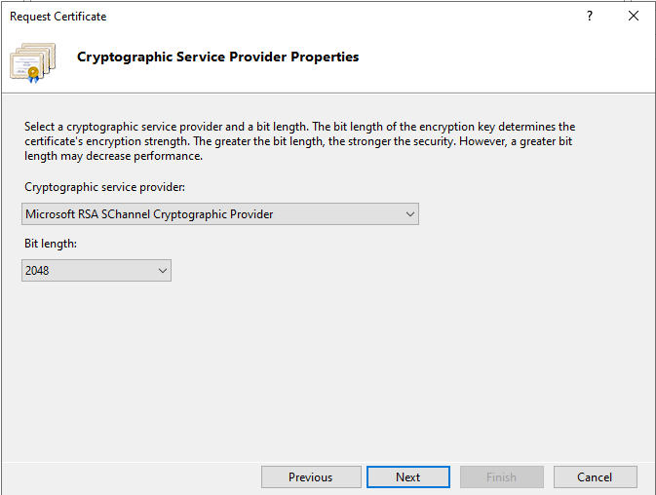
- Specify file name and click on finish.
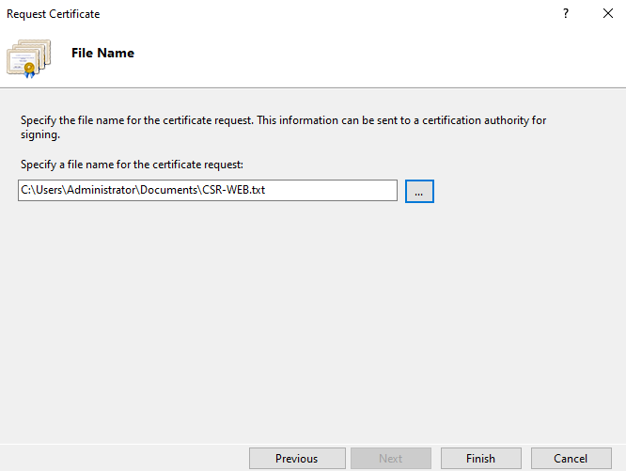
- Open the CSR file in notepad and copy all the content of it.
- Open the CA server web page in browser and click on request a certificate option.

- Click on advanced certificate request.

- Paste the CSR content, select web server template and provide additional attributes in below format and click submit.
san:dns=web.shiv.com
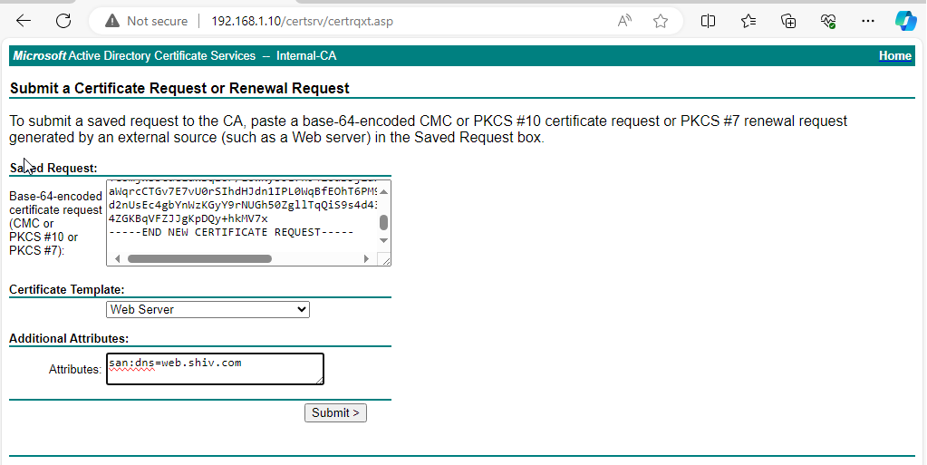
Note: If you are generating Certificate for multiple web applications then please add all the web applications FQDN in additional attributes(san:dns=web.shiv.com&dns=web2.shiv.com&dns=web3.shiv.com). Doing this will benefit us to use this single certificate on multiple applications.
- Download both certificate and certificate chain.
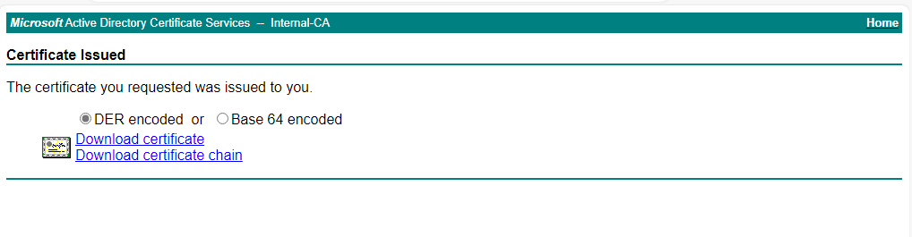
Step 4: Installing Certificate on the Server and Client machine.

- Open IIS and click server certificate and complete certificate request and provide the location of the downloaded certificate and give a friendly name for identification and click OK. Certificate will be installed.
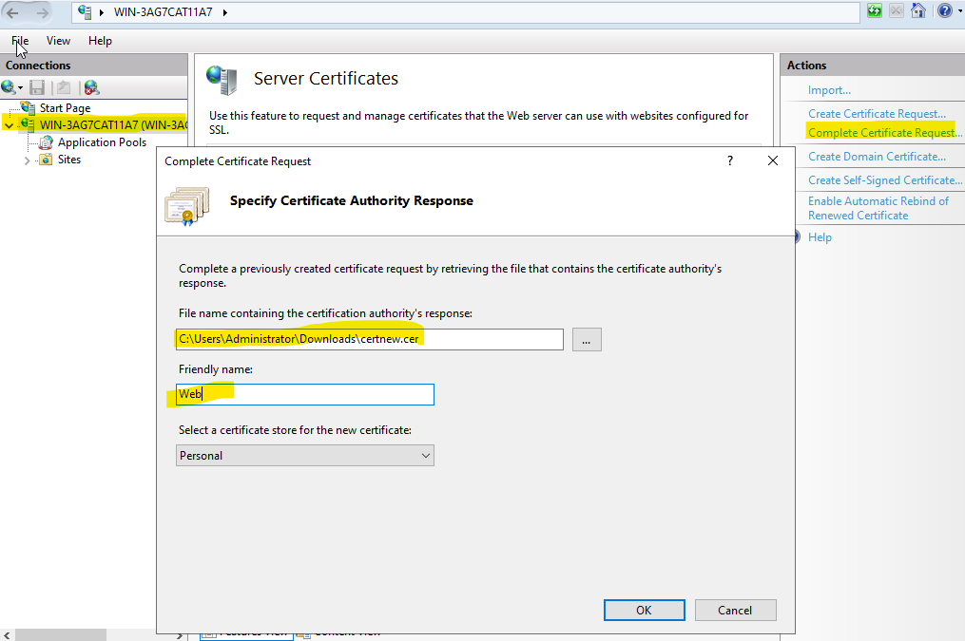

- You can view your certificate in IIS.
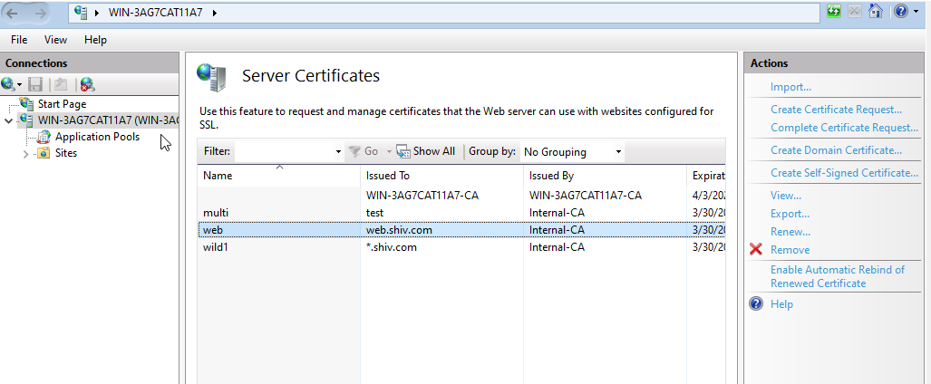
- Install the chain certificate in Trusted Root Certification Authorities.
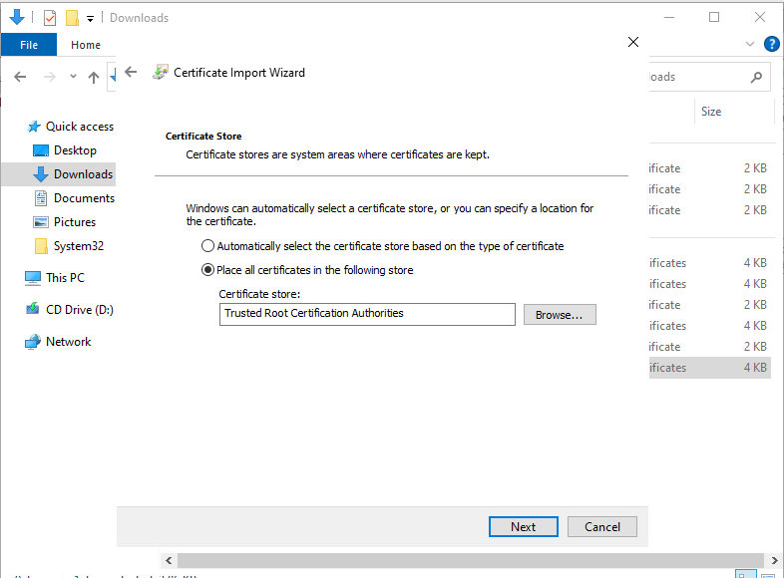
- You can verify installation of the Root CA in Certificate page.
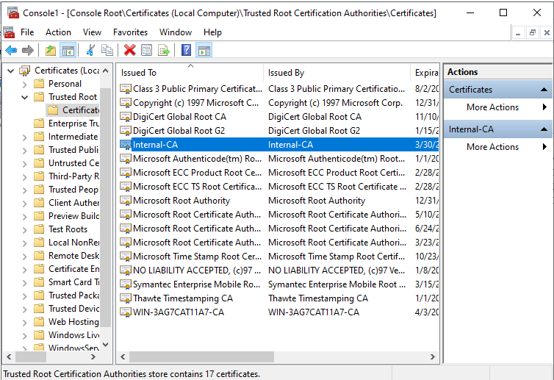
- Now configure the website with SSL certificate configured.
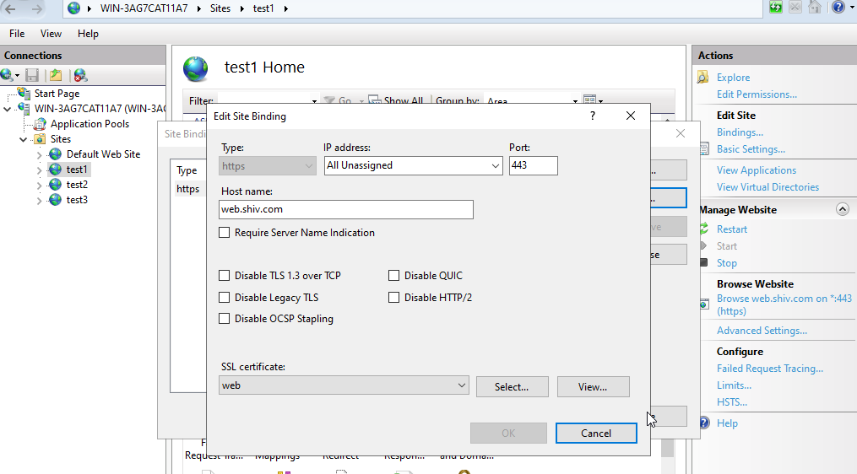
- Browse the website in browser and you will see the valid certificate sign.
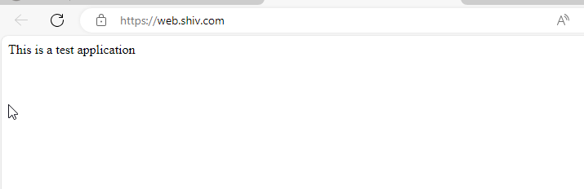
Step 5: Exporting the certificate in PFX or PKCS12 format.
- Open IIS and click on the server name and open server certificates.
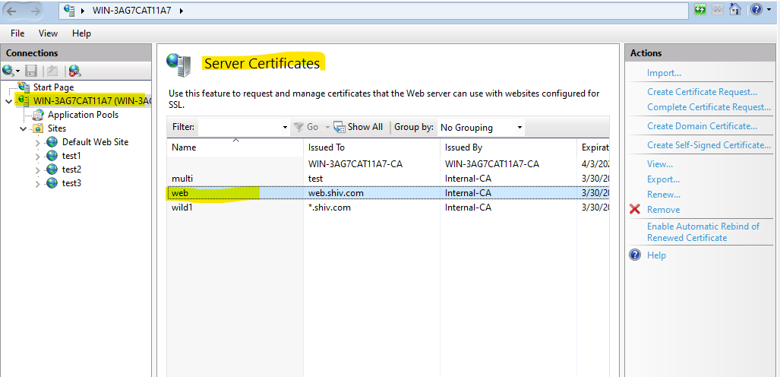
- Select certificate and click on export.
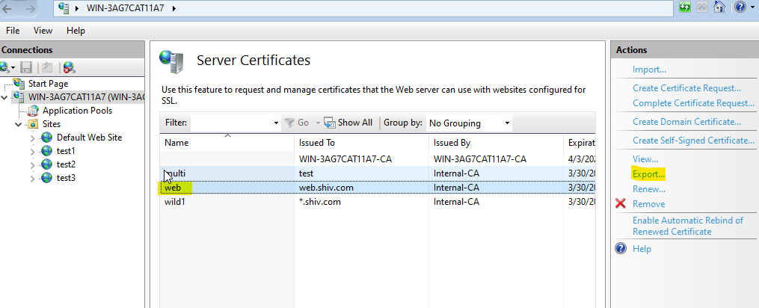
- Specify the location to save the certificate and provide the password and click on OK.
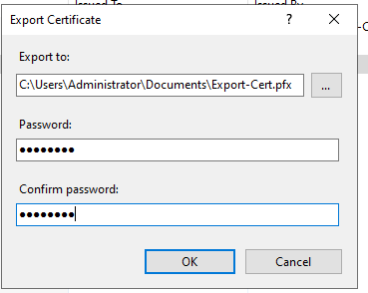
Note: Password mentioned above will be used in installing the certificate on the other server’s.
- Go to the specified location and you will find your certificate in pfx format.
